Summary of NAW21 Partner Activity
YNY LEP/Growth Hub
Employer event- 9th Feb, 12:30-13:30. https://www.ynygrowthhub.com/events/leverage-apprenticeships-to-build-back-better/ and launch of updated Employer Apprenticeship Toolkit.
Yorkshire Post article, written by Danny MacFarlane of Ellis Patents to be published on 9th Feb.

Careers & Enterprise Company, delivered by NYBEP for YNY LEP
Monday 8th February
National launch of NAW 2021 – Build the Future.
08:30 – 09:30 Career Leader Session – Get Involved
An opportunity for Career Leaders to find out about NAW21 and to access up to date information on the support available to support young people with providing information on Apprenticeships. Register in advance for this meeting on the link below:
https://us02web.zoom.us/meeting/register/tZEkdOmspjsoH9JTBLYXqztN2CdblZk0Wshm

Tuesday 9th February
12:00-16:00 UCAS Discover Apprenticeship Exhibition
A live exhibition giving learners the opportunity to meet and speak to big brand employers and apprenticeship providers. Register in advance via the link:
https://www.ucas.com/events/discover-apprenticeships-exhibition-387746

11:10 – The Big Assembly
During the live broadcast, the panel will discuss all things apprenticeships, traineeships and a range of career opportunities. Students and teachers can join the event live to ask questions to the panel.
Register for The Big Assembly via the link:
https://www.bigassembly.org/

12:00-14:00 Ask An Employer Q&A Session
Employers will be joining us on Twitter @NYBEP as part of the national campaign. Young people, parents and carers can get involved by asking questions through the #AskAnEmployer tag.

Wednesday 10th February
11:00-18:00 National Apprenticeship Show
Click here to register - The National Apprenticeship Show (vfairs.com)
12:00-14:00 Ask An Apprentice Q&A Session
Apprentices will be joining us on Twitter @NYBEP as part of the national campaign. Young people, parents and carers can get involved by asking questions through the #AskAnEmployer tag.
17:00-18:00 Facebook Live Q&A Session - @York Apprenticeships page.

Thursday 11th February
16:00-17:00 NAW21 Parents and Carers Apprenticeship Free session
This session is open to parents and carers who wish to find out more about apprenticeships and explore what support is available to your young person who is considering this pathway. There will also be opportunity to ask any questions.
Register in advance for this meeting:
https://us02web.zoom.us/meeting/register/tZYtceqsrzoqGNIkB2c_7zBYxZpdrGGQAHpG

Friday 12th February
Live Apprenticeship Information Sessions – Microsoft Teams to register your interest please email askteam@nybep.org.uk
Schools and Colleges are invited across the week to access ‘live sessions’ or pre-recorded sessions that have been prepared for NAW – these sessions aimed at Year 10 and above are:
What is an Apprenticeship? – impartial information sessions that provides an overview of what an apprenticeship is, the levels available and some hints and tips on where to look for one.
Higher and Degree Apprenticeships – impartial information session
Apprenticeship session for Parents – impartial information session aimed at parent who would like to find out more about Apprenticeships.
Please email askteam@nybep.org.uk to access the sessions.
Access to a full suite of resources: www.amazingapprenticeships.com

City of York Council- Facebook event, Wed 10 Feb, 5pm
Hosting an annual event to promote the benefits of apprenticeships, and showcase the resilience of apprentices and employers during the pandemic. This year’s theme is ‘build the future’ and focuses on training, retaining skills and achieving.

A panel of apprenticeship experts will be on hand to answer any questions businesses have about apprenticeships through a live Q&A at 5pm on Wednesday 10 February on the council’s facebook page – visit to see the live chat facebook.com/CityofYork
Scarborough TEC
Hosting National Apprenticeship Week IAG event on Tuesday 9th February from 5-5.30pm.
Anyone interested can register on the link below: https://scarboroughtec.ac.uk/virtual-open-events/
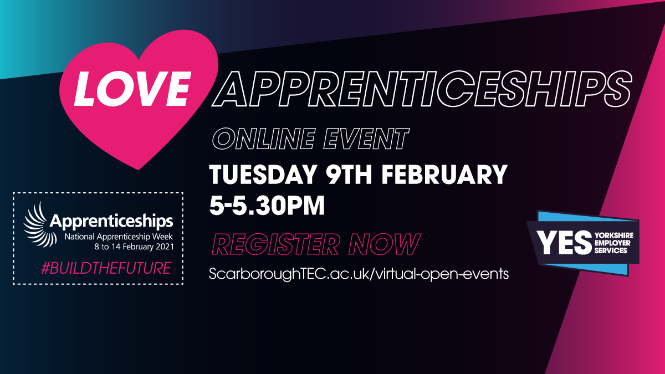
Selby College
Hosting an Employers Business Breakfast. Join them for an informal virtual networking session during National Apprenticeship Week and discuss how we can help businesses upskill their workforce. Thursday 11th February, 8.30-9.30am Visit our website to book a place.
Derwent Training

Derwent Training are holding a Virtual Open Evening on Thursday 11th February. This will be in a presentation and video format that attendees will receive a link to access.
Everyone interested will need to register here: https://www.eventbrite.co.uk/e/virtual-apprenticeship-open-evening-tickets-138436131195

York St John University
8-15 February Throughout the whole of National Apprenticeship week, YSJ will be sharing useful information, news and updates - including a webinar on their Data Science Degree Apprenticeship. For all the latest YSJ apprenticeship news and events, follow them on social media. YSJ For Business

